**Project Planning Phase**

**SPRINT DELIVERY - 3**

|  |  |
| --- | --- |
| Team ID | PNT2022TMID24776 |
| Project Name | Project – Smart Farmer-IoT based Smart Farming Application |
| Maximum Marks | 8 Marks |

**Mobile web App: MIT APP INVERTER**

Creating the web app using the MIT app inverter

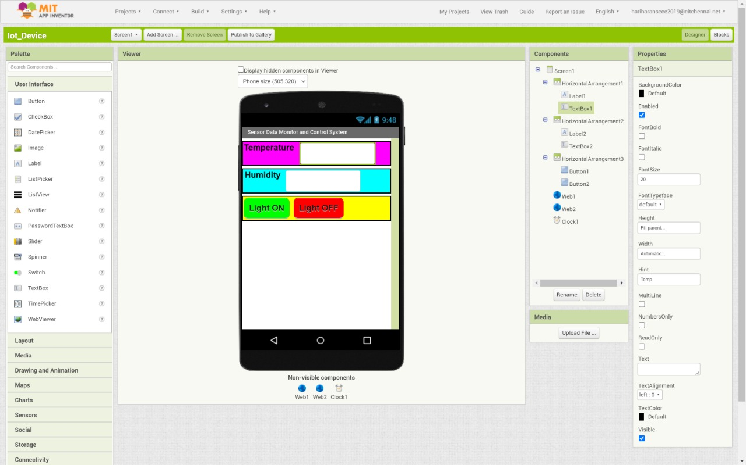

**Creating steps:**

* To create MIT app, go to the MIT inverter website.
* After signing up with the required details login to the website.
* We can start building the application using the tools, palette, layout, media, etc.
* Click and drag the required buttons to design the UI.
* Complete the UI works and check the interface.
* We should add the clock as hidden component.

**Modules and testing of the app:**

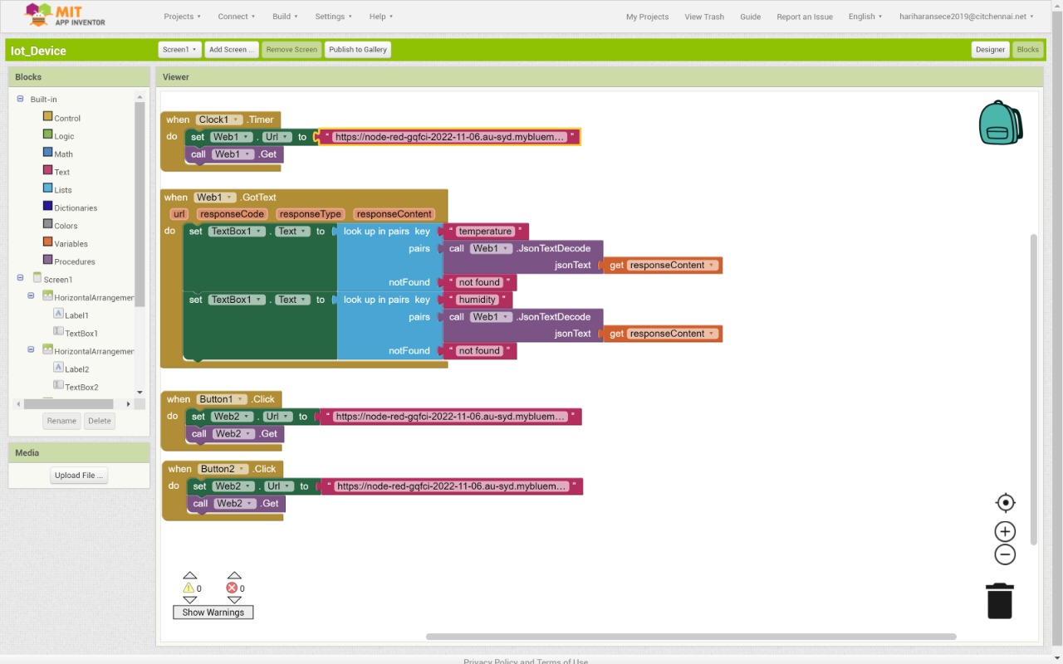

* After adding the clock and web as invisible components, do the backend work.
* Map every column with URL, response code, response content.
* Textbox 1, Textbox 2 and Textbox 3 are mapped as rows.
* Button1 and button2 are intialized to get URL.
* Enter the URL in the preffered buttons.
* MIT APP will run on the android emulator.